**The profoundly reshaped of Manufacturing Industry through ‘Block chain+Intelligent manufacturing’**

The rapid development of information technology are changing and influencing every aspect of human beings’ life. Broadly speaking, the history of human’s development is accompanied by the upgrading of information technology, during which information technology revolutions happened for five times. Every time, substantial improvement has been brought to the social productivity, thus contributing to the renovation and upgrade in the relations and modes of production.

With the development of information technology, Internet 2.0 technology "Block Chain" came into being，which was a decentralized distributed account database with the characteristics of decentralization, openness, transparency, non-tampering, traceability etc.

The Block Chain contains a list called a block with a record of continuous growth and orderly arrangement. Each block contains a timestamp and a link to the previous block and the data cannot be tampered with through block chain designed. Also once it been recorded, the data in the block will not be reversible.

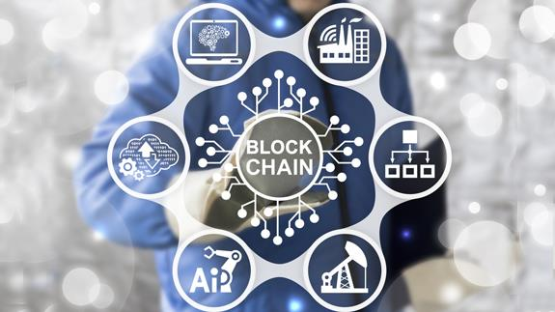

Intelligent manufacturing is a human-computer integrated intelligent system composed of intelligent machines and human experts. It can perform intelligent activities in the manufacturing process, such as computer analysis, reasoning, judgment, conception and decision make. We expand, extend, and partially replace the mental work of human experts in the manufacturing process through working with intelligent machines. It renews the concept of automatic manufacturing and makes it flexible, intelligent and highly integrated.

At present, there are widespread pain points in the manufacturing industry, such as unsymmetrical information, unshared resources, unbalanced interaction, unresponsiveness, weak core technologies, and difficulties in maintaining property rights, which severely constrain the development of the manufacturing industry.

Based on the characteristics of Block Chain technology，it can be used into the manufacturing enterprise system connection composed of sensor connection, module control, communication systems, ERP systems and so on. Through unified account infrastructure, enterprises, manufacturers and safety production supervision departments can monitor all aspects of manufacturing in a long-term and continuous way, and improve the safety and reliability of manufacturing process. Meanwhile, the traceability and non-tamperability of the block chain account book record is also conducive to the development of enterprise audit, which makes it eaiser to identify problems, track problems, solve problems and optimize systems, which highly improves the manufacturing process and intelligent management.

On 5th March 2018, China’s prime minister Keqiang Li said on the government work report: "Speed up the conversion of kinetic energy development, carry out in depth of the‘Internet+’action, implement inclusive and prudent supervision, promote big data, cloud computing, Internet of things applications. Emerging industries are booming and traditional industries have been deeply reshaped. Implementing "Made In China 2025" strategy, and promoting industrial strong foundation, intelligent manufacturing, green manufacturing and other major projects, and accelerate the development of advanced manufacturing."

Ms Fan Yiyang，founder of IM Chain also spoke to journalist about creating an ecological platform which based on Block Chain technology, information oriented, and data requirement directly driven.

It is a global and open ecological system where safety, convenience and intelligence are, the allocation of resources and energy is optimized, and the quality improvement of products is maximized which deep fusion of Block Chain technology and intelligent manufacturing technology.

To build a safe, mutual trust and efficient bridge between the participants of the global intelligent manufacturing ecosystem, to provide a low-cost, high-income and private means of communication for every participant in the intelligent manufacturing system, and to maximize the emancipation of productivity. Leading global manufacturing to revolutionize, brand-new relations of production and building a healthy and prosperous intelligent manufacturing ecosystem.

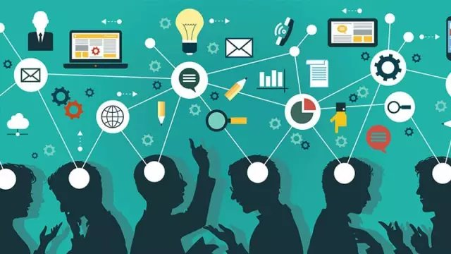

In the future, we will look forwards to the creative change of the new ecology, which effectively combined of block chain and intelligent manufacturing.